Quiz 1: System Architecture Day 1

**System Architecture Day 1**

**1. QUESTION**

An ERP application is deployed in multiple Availability Zones in a single region. In the event of failure, the RTO must be less than 3 hours, and the RPO is 15 minutes. The customer realizes that data corruption occurred roughly 1.5 hours ago. Which DR strategy can be used to achieve this RTO and RPO in the event of this kind of failure?

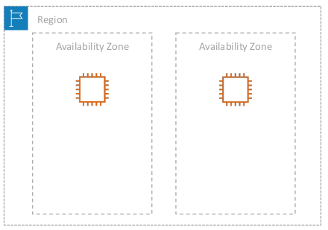

Ảnh có chứa biểu đồ, ảnh chụp màn hình, hàng, văn bản

Mô tả được tự động tạo

**Option 1:** Take 15-minute DB backups stored in Amazon Glacier, with transaction logs stored in Amazon S3 every 5 minutes.

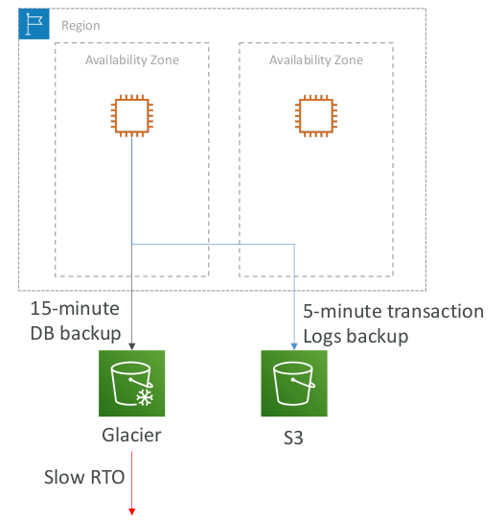

**Option 2:** Use synchronous database master-slave replication between two Availability Zones.

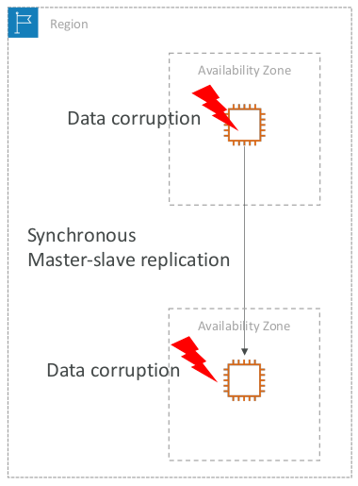

**Option 3:** Take hourly DB backups to Amazon S3, with transaction logs stored in S3 every 5 minutes

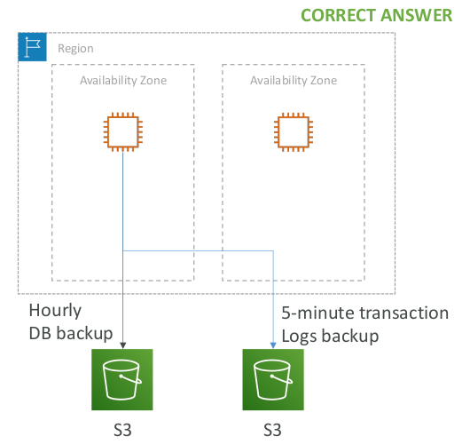

**Option 4:** Take hourly DB backups to an Amazon EC2 instance store volume, with transaction logs stored in Amazon S3 every 5 minutes

